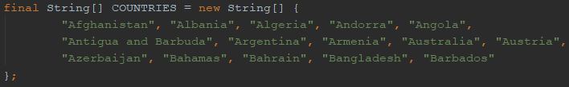

This is to create an array of Strings. The array is named COUNTRIES.



This is to attach country_list_view object’s id to variable myListView of type ListView.



This is to create an ArrayAdapter named aa. This array adapter will generate a ListView with each component is a TextView contain the content of 1 item in COUNTRIES array and have a layout defined by simple_list_item_1.



This is to apply the ListView layout created by the aa adapter to myListView.